Cognizant Technology Solutions

|  |  |
| --- | --- |
| Name | Jirra Mahalakshmi |
| Associate ID | 844554 |
| Cognizant Designation | Programmer Analyst |
| Contact Number | +91 8309716370 |
| Email Address | 844554@cognizant.com |
| Current Job Title | Programmer Analyst |

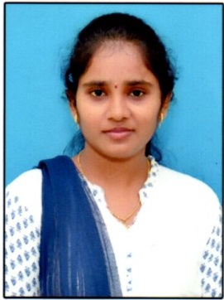

**OBJECTIVES**

To achieve high career growth through a continuous learning process, keep myself dynamic, visionary and competitive with the changing scenario of the world and to contribute for the growth of organization.

**WORK EXPERIENCE**

Joined “**COGNIZANT TECHNOLOGY SOLUTIONS**” as “**Programmer Analyst Trainee**” on December 2019 – Present.

**PROJECT EXPERIENCE**

1. I have been working for project **'MattelB2B NAD Implementation'** under EAS Salesforce (March 2021 - Present).
2. I have worked on **'MattelB2B NAD'** under EAS Salesforce (December 2020 – March 2021).
3. I have worked on **'Mattel Digital Ecom Staff Aug'** under EAS (Sep 2020 – Dec 2020)
4. During training we have worked on **'PIXOGRAM'** (3 months).

**TECHNICAL SKILLS**

Programming Languages **:** Basics of Java.

Web Technologies : HTML, CSS, Bootstrap, Angular

Web/Application Server : Tomcat

Operating System : Windows

Tools : Eclipse, VS Code, Git

Database : MySQL

**EDUCATIONAL QUALIFICAITON**

|  |  |  |  |
| --- | --- | --- | --- |
| Degree | School / University Name | Year of Graduation | Aggregate |
| B.Tech(Computer Science and Engineering) | Sree Venkateswara College of Engineering, Nellore | 2019 | 77.25 |
| Board of Intermediate | Narayana Junior College, Nellore | 2015 | 96.20 |
| Board of secondary (SSC) | ZPP High School , Jaladanki | 2013 | 7.5 |

**SOFT SKILLS**

1. Good Analysing Capacity.
2. Good Communication Skills.
3. Willing to learn new Technologies which improves my knowledge.

**DECLARATION**

I hereby declare that the information stated above is true and correct to the best of my knowledge.

Place: Nellore

Date: (Jirra Mahalakshmi)